Baton Rouge RC Club Newsletter – September 4, 2007

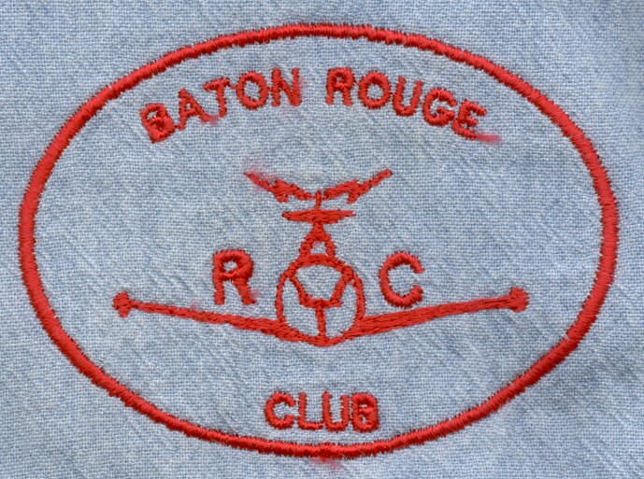
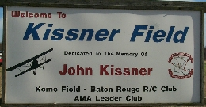
PRESIDENT: Farley Phillips
VICE PRESIDENT: Mike Goetzman
SECRETARY: Richard Mason
TREASURE: David Magee
EDITOR: Pat Beard
Telephone: (225)654-8162
E-mail: pcbeard@cox.net

________________________________________________________________________________________________________
NOTICE:
The next meeting of the BRRCC will be Tuesday, Oct. 2nd at the Greenwell Springs Rd. Library at 7:00pm
_______________________________________________________________________________________

WOW!!! It has been hot. I must admire those that enjoy flying so much that they endure this weather. It is time for the high pressure to move on and allow some of the rain that has plagued the states to our north to come on through and reduce our temperatures. At least the high pressure did steer Hurricane Dean away from the Gulf Coast.

I did manage to make it out to the field on August 23rd and there were a few of the die hard RCers there and during the shot time I was there a plane was always in the air. What was odd was that Marvin flew more than anyone and he didn’t even have a plane with him.

Attached are some pictures I took while at the field. I regret I didn’t get a picture of Mickey Genre with his Great Planes ¼ scale RV4. I did see it fly with Marvin at the controls and he said it is a great flyer. Mickey owns a full size RV4.

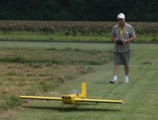
Blackie LeJeune was flying his Chuck Cunningham Lazy Ace. Talk about a beautiful
plane in the air. It lives up to its name – Lazy Ace.
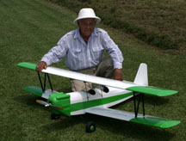

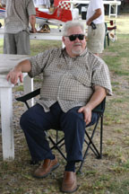

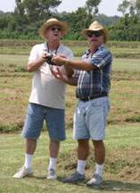
Richard Mason, with the help of Marvin, flew an Eindecker.
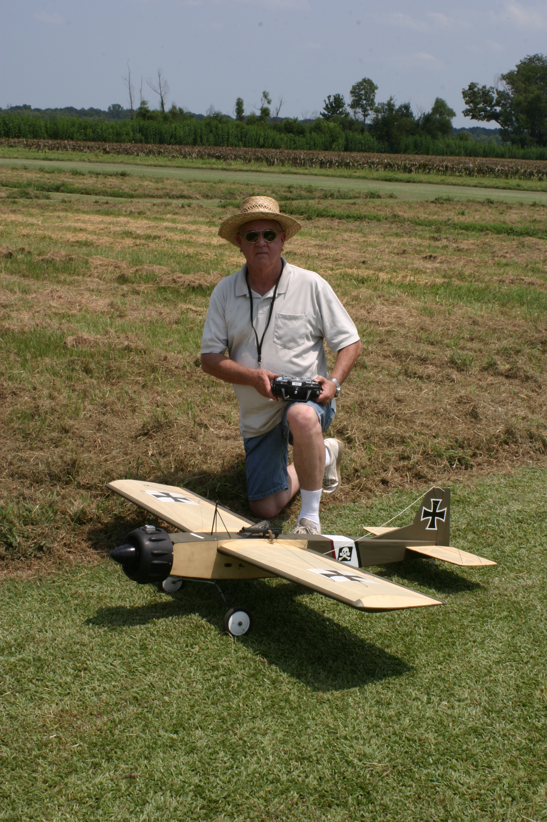
The Eindecker is built from a highly modified Great Planes Easy Sport. This is a great looking plane.

Weldon Sharon is taxiing his Katana back to the pit area.

I think Willard Beard has the best idea. He sat in the shade where there was a light breeze blowing.

Summary of Detailed Discussion of BRRCC Field Maintenance Responsibilities

For those of you that do not receive e-mail messages, there have been some discussions on field maintenance responsibility. This summary of the discussion held at the September 4th regularly scheduled meeting is written by President Farley Phillips.

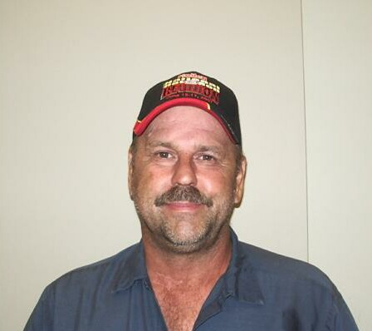
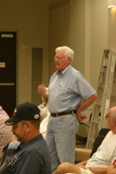
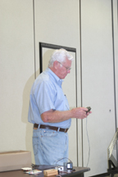
The long awaited and apparently long overdue discussion of who is supposed to be responsible for large tractor bush-hogging and weedwacking duties was the major topic of discussion at the last BRRCC meeting. Vic Jines took some photos last Thursday of the BRRCC field just after Blackie had freshly manicured it with the mower. Vic's intention was to forward it to the Sunday flyers to stir up a "little friendly competition" between groups. The message he was trying to send was that the Sunday flyers were not keeping up their end of the bargain to weedwack. The Sunday group has significantly decreased in size and there are only a few Sunday flyers left. Afterwards a flurry of e-mails went back and forth following Vic's e-mail. A heated debate of a newly divided BRRCC groups, the Thursday flyers pitted against the Sunday flyers. Someone along the line, Vic discovered that there was a document generated in 2006 that spelled out field maintenance duties and assigned responsibilities. On that list were 5 names of persons "qualified" and assigned to use the big tractor for bush-hogging. Karl's name was not on that list. His sole responsibility from the beginning was to keep up equipment. Karl has been doing a bang-up job of that as well as busting his tail trying to weedwack and bush-hogg regularly. Karl was offended by e-mail comments. Vic came to the meeting and publicly apologized to Karl. Vic then suggested at the meeting that we purchase a $330.00 sprayer attachment that hooks to our tractors. He then proposed that we buy chemical Round-Up type spray to ride along, including the road, and spray both sides, making weed control a thing of the past. This issue was discussed thoroughly and it was voted on that major spraying of the road would interfere with crops and cause possible havoc. Willard said that spraying the weedy areas regularly, including cross ties and under tables would eliminate most weedwacking. Blackie, Karl, and many others discussed their feeling on the issue in open forum. Mickey Genre simply stated that this sounds like a general lack of communication, that members should pull together and step up to the plate, the basic problem would go away if we just put out heads together, helped each other, and just did a better job of communicating in general. We just need to cut out the finger pointing,

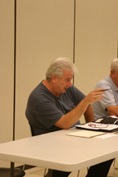

Farley is NOT finger pointing but stating that a weed problem is not going to split this club.

Remember that we all belong to one great club, the BRRCC, and all should do our part to protect and preserve the wonderful facility that we are allowed to use, thanks to the Kissners. It was finally agreed that the Thursday flyers would take care of all mowing and bush-hogging and what is left of the Sunday flyers would take care of weeds, with Karl Boggs’s help and leadership.

All is well.

Vic Jines was the program speaker and showed the group his home made device he uses to trickle charge his plane to keep them ready for the next flying session. He created lots of interest and discussion.

Editor – Pat Beard

